|  |  |
| --- | --- |
| Test Name | UC06 Reject Loans |
| Use Case Tested: | Reject Loans |
| Test Description: | Tests when a borrower has selected and completed their loan choices that they are able to reject their pending loans and restart the scanning process. |
| Pre-conditions | The program is on the “Confirm Loans” panel.  The borrower has a list of pending loans on screen. |
| Post-conditions | System shows the “Scanning” panel.  Borrower details are displayed.  Existing loans are displayed.  Pending loan list is empty.  Cancel button is enabled.  Card Reader is disabled.  Book Scanner is enabled. |
| Notes: |  |

|  |  |  |
| --- | --- | --- |
| Data 1 Attempt | |  |
| Result (Pass/Fail/Warning/Incomplete) | Fail | |

|  |  |  |  |  |
| --- | --- | --- | --- | --- |
|  | TEST STEP | EXPECTED TEST RESULTS | P | F |
|  | Borrower presses the “Confirm” button on the “Confirm Loans” panel. | System shows the “Scanning” panel. | P |  |
|  |  | Borrower details are displayed. | P |  |
|  |  | Existing loans are displayed. | P |  |
|  |  | Pending loan list is empty. |  | F |
|  |  | Cancel button is enabled. | P |  |
|  |  | Card Reader is disabled. | P |  |
|  |  | Book Scanner is enabled. | P |  |

Note: The pending loans and current book panels are still filled.

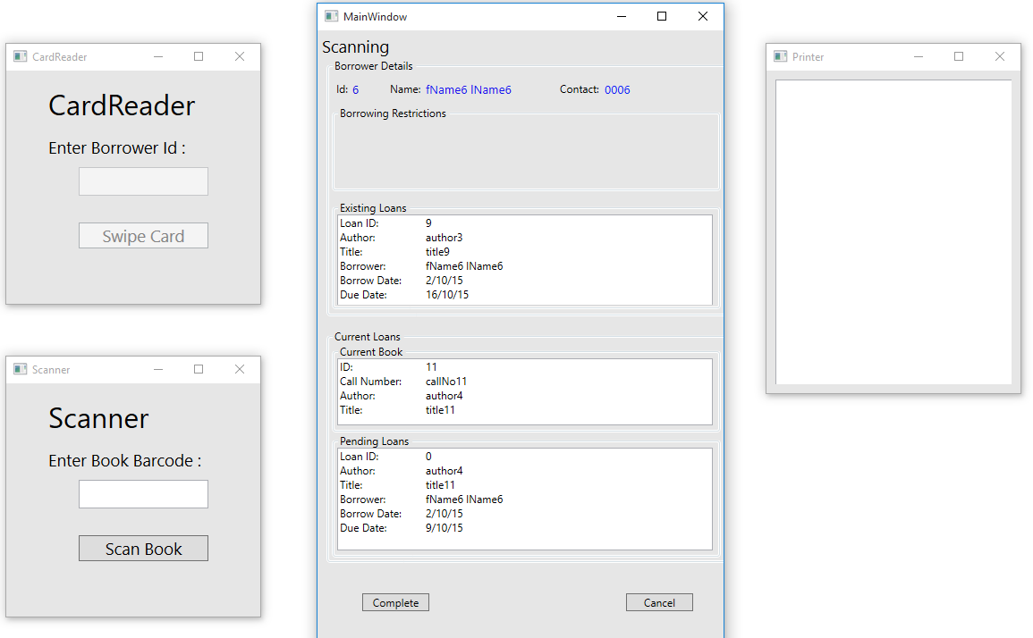

|  |  |  |  |  |  |
| --- | --- | --- | --- | --- | --- |
| Test Data Table | | | | | |
|  | **Member** | **Book** | **3** | **4** | **5** |
| Data 1 Attempt | 6 | 10 |  |  |  |
|  |  | 11 |  |  |  |
|  |  |  | Complete |  |  |
|  |  |  | Reject |  |  |